Exercise 1

WEBD1000

Carlos Ramos – W0467831

Chosen website: <https://darksouls.wiki.fextralife.com/Dark+Souls+Wiki>

## Screenshot 1 – Original website:

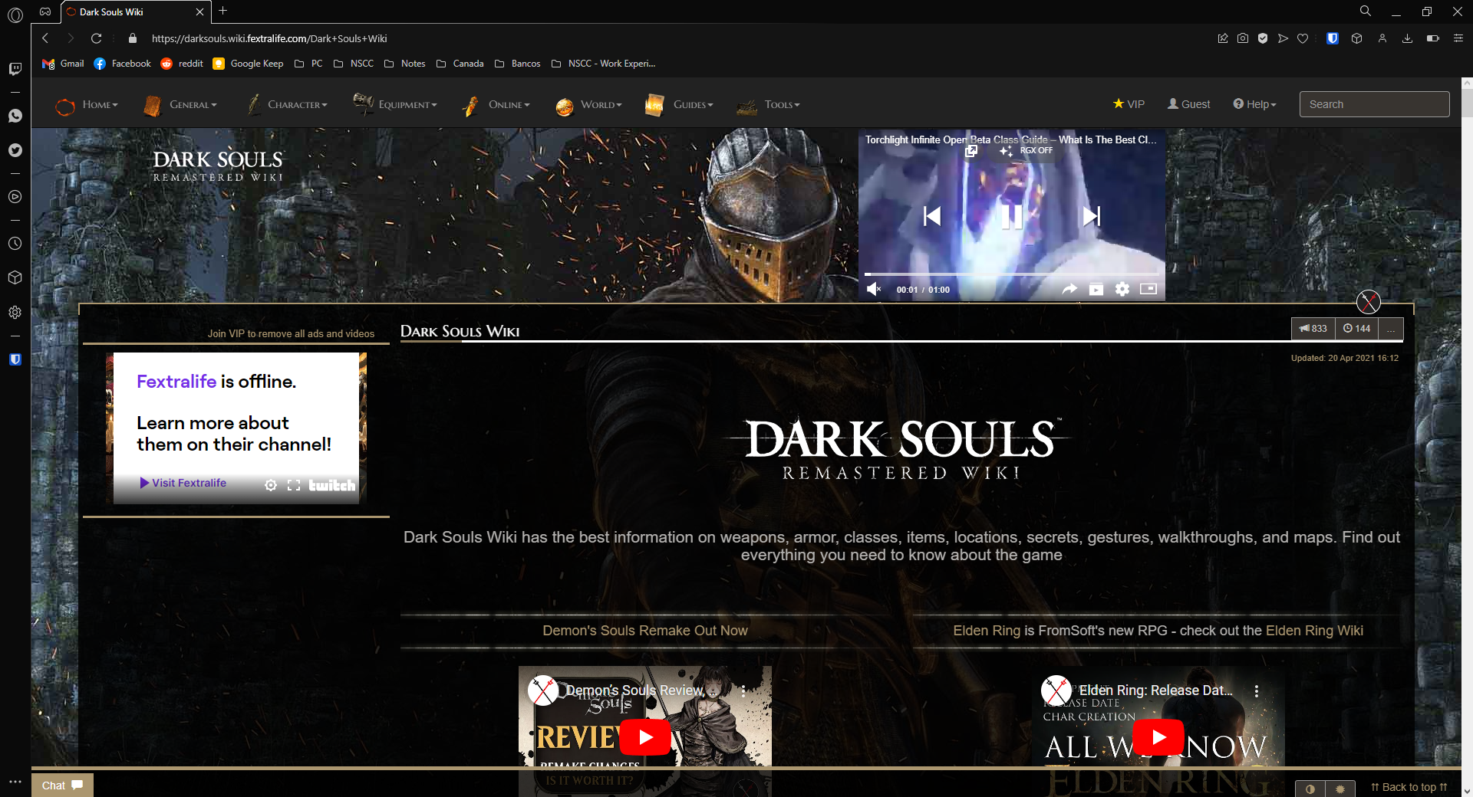

## Screenshot 2 – Altered website:

## Screenshot 3 – Background picture changed and code:

## Screenshot 4 – Splash picture changed and code:

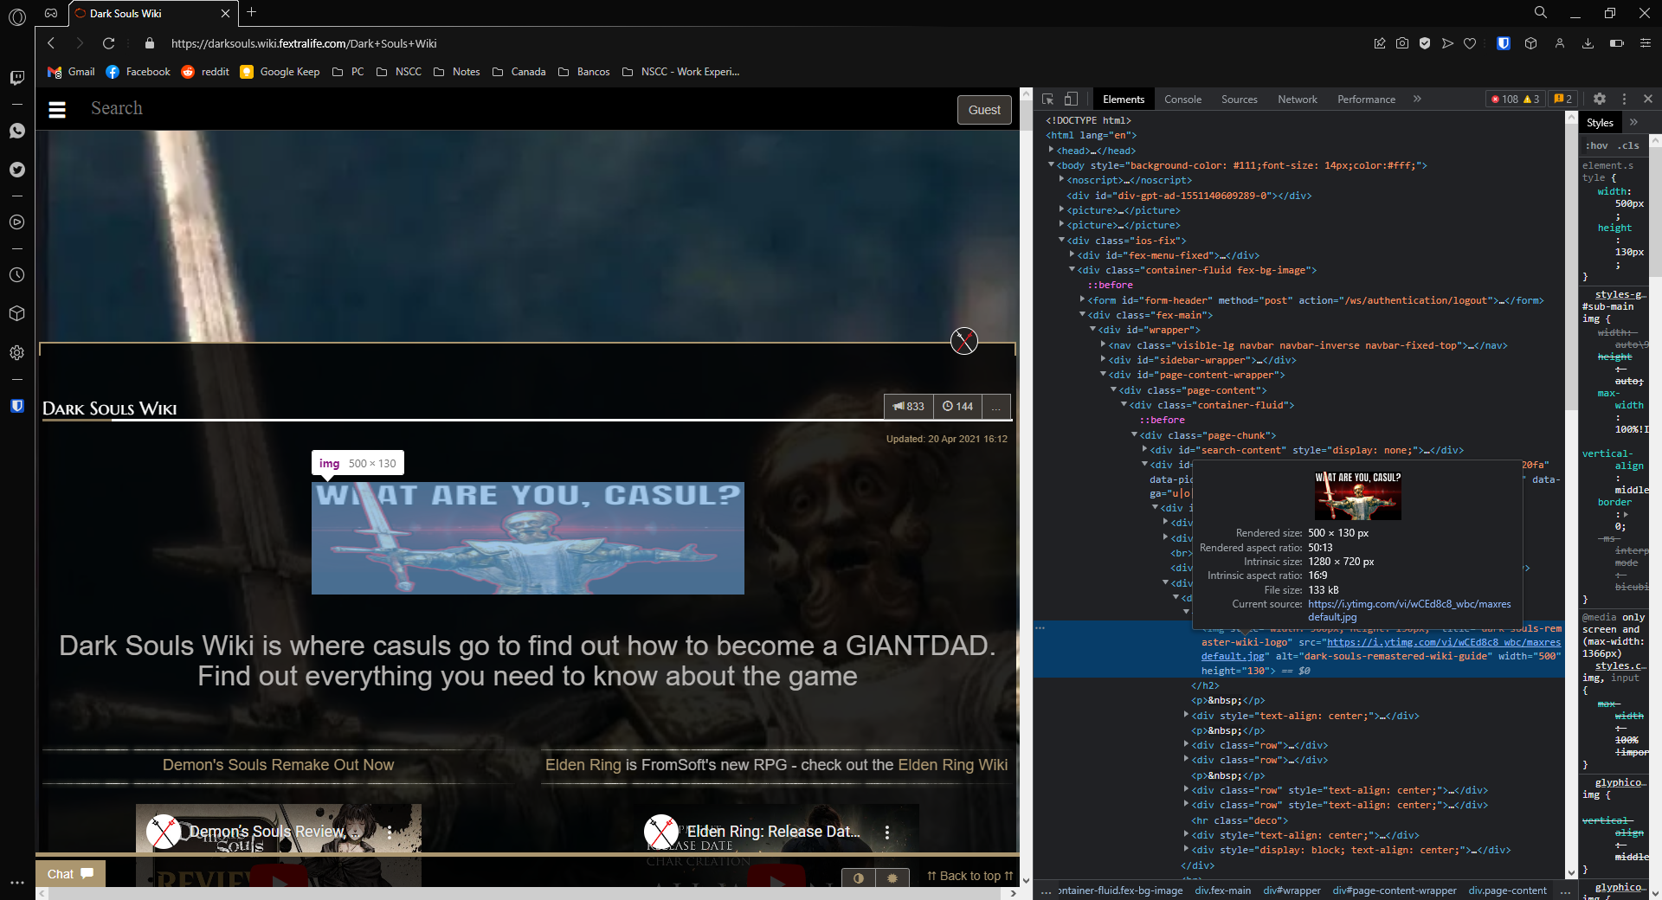

## Screenshot 5 – Initial paragraph rewritten:

## Screenshot 6 – Initial paragraph style changed (font increased and color changed):

